[Control LEDs with Voice Command | Arduino-Bluetooth module tutorial](http://mechstuff.com/control-leds-with-voice-command-arduino-bluetooth-module-tutoria/)

Requirements :-

1. Arduino board
2. Breadboard
3. Jumpers/single stranded wires
4. RGB led
5. Bluetooth module HC-05
6. Android Smart Phone

### Connections Of Bluetooth module HC05 :-

* **VCC** – to VCC of Arduino.
* **GND** – to GND of Arduino.
* **RX** – to digital pin 0(TX pin) of Arduino.
* **TX** – to digital pin 1(RX pin) of Arduino. (connect RX & TX pin after uploading the code)

### Of LED –

Note that you connect the terminals to PWM pins only !

* Longest terminal (2) – VCC
* Terminal 1  – Pin 9
* Terminal 3 – Pin 10
* Terminal 4 – Pin 11

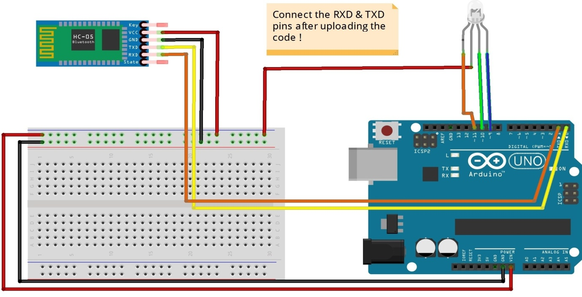

NOTE :-

2 types of RGB led are available in the market – common anode & common cathode. Here I’m using common anode . If you are using common cathode, connect the longest terminal to GND pin of Arduino; rest all the connections are same.

### Procedure :-

1. Make the connections as shown in the above image. Don’t connect the RX & TX pins WHILE/BEFORE  uploading the code !
2. Copy the code given below.
3. Download the app called **BT Voice Control**/**AMR Voice**(It’s free).
4. Open the app **AMR Voice**app (It will automatically turn on the device’s Bluetooth). Go to options. Click on “Connect to Robot”. Choose the device – HC 05.
5. When you are connecting to the Bluetooth module for the first time, it will ask you the password. Enter **0000**OR **1234.**
6. When the device gets successfully paired with the sensor, the LED lights on sensor will start blinking at a slower rate than usual.
7. DONE. Copy the code given below & test it out !

CODE:-

string voice;

#define GREEN 10

#define BLUE 11

#define RED 9

void setup()

{ // put your setup code here, to run once:

Serial.begin(9600);

pinMode(GREEN, OUTPUT);

pinMode(BLUE, OUTPUT);

pinMode(RED, OUTPUT);

analogWrite(RED,255);

analogWrite(GREEN,255);//Since LED must be off in the beginning

analogWrite(BLUE,255);

}

int redVal;

int greenVal;

int blueVal;

void loop() {

while (Serial.available()) //Check if there is an available byte to read

{

delay(10); //Delay added to make thing stable

char c = Serial.read(); //Conduct a serial read

if (c == '#') {break;} //Exit the loop when the # is detected after the word

voice += c; //Shorthand for voice = voice + c

}

if (voice.length() > 0) {

Serial.println(voice);

//----------Control Multiple Pins/ LEDs----------//

if(voice == "*red")// FOR RED COLOUR OF THE LED

{

analogWrite(RED,0);

analogWrite(GREEN,255);

analogWrite(BLUE,255);

}

else if(voice == "*green")//FOR GREEN COLOUR OF THE LED !

{

analogWrite(GREEN,0);

analogWrite(RED,255);

analogWrite(BLUE,255);

}

else if(voice == "*blue")//FOR BLUE COLOUR OF THE LED !

{

analogWrite(RED,255);

analogWrite(BLUE,0);

analogWrite(GREEN,255);

}

else if(voice == "*white")//FOR WHITE COLOUR OF THE LED !

{

analogWrite(RED,0);

analogWrite(GREEN,0);

analogWrite(BLUE,0);

}

else if(voice == "*good night")//FOR TURNING OFF LED !

{

analogWrite(RED,255);

analogWrite(GREEN,255);

analogWrite(BLUE,255);

}

else if(voice == "*chameleon") // FOR FADING/CHANGING COLOURS !

{

redVal = 255; // choose a value between 1 and 255 to change the color.

blueVal = 0;

greenVal = 0;

for(int i = 0; i < 255; i += 1) // fades out of red and into full (i = 255) green

{

greenVal += 1;

redVal -= 1;

analogWrite(GREEN, 255 - greenVal);

analogWrite(RED, 255 - redVal);

delay(10);

}

redVal = 0;

blueVal = 0;

greenVal = 255;

for(int i = 0; i < 255; i += 1)

{

blueVal += 1;

greenVal -= 1;

analogWrite(BLUE, 255 - blueVal);

analogWrite(GREEN, 255 - greenVal);

delay(10);

}

redVal = 0;

blueVal = 255;

greenVal = 0;

for(int i = 0; i < 255; i += 1)

{

redVal += 1;

blueVal -= 1;

analogWrite(RED, 255 - redVal);

analogWrite(BLUE, 255 - blueVal);

delay(10);

}

}

voice=""; //Reset the variable after initiating

}

}

### Connections & Code for controlling normal LED with Voice commands :-

#### Connections :-

Just replace RGB led with normal LED & connect the positive terminal to any PWM pin(here 9)

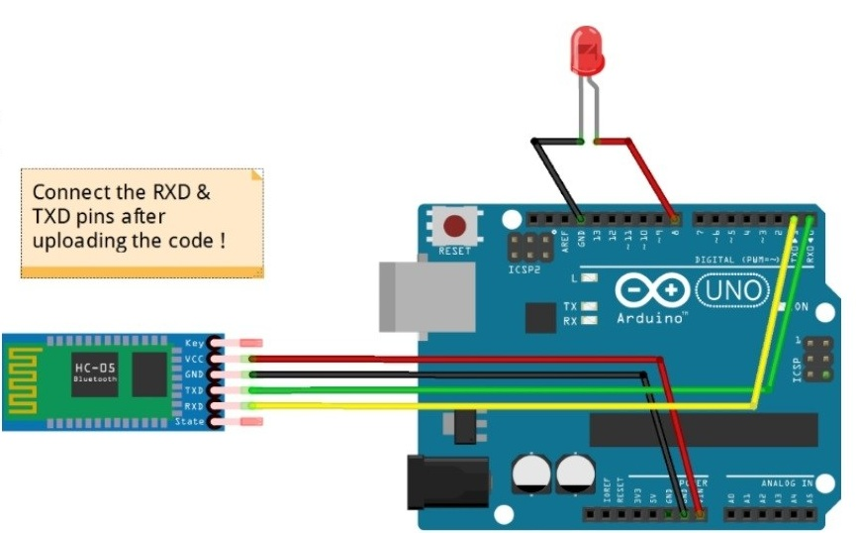

#### Code :-

string voice;

#define led 9

void setup() {

// put your setup code here, to run once:

Serial.begin(9600);

pinMode(led,OUTPUT);

}

void loop() { // put your main code here, to run repeatedly:

while (Serial.available())

{ //Check if there is an available byte to read

delay(10); //Delay added to make thing stable

char c = Serial.read(); //Conduct a serial read

if (c == '#') {break;} //Exit the loop when the # is detected after the word

voice += c; //Shorthand for voice = voice + c

}

if (voice.length() > 0) {

Serial.println(voice);

//-----------------------------------------------------------------------//

//----------Control Multiple Pins/ LEDs----------//

if(voice == "*good morning") {digitalWrite(led,HIGH);}

else if(voice == "*good night"){digitalWrite(led,LOW);}

else if(voice == "*fade")

voice=""; //Reset the variable after initiating

}

}